Plant | What does it look like? | Symptoms
Lilies | 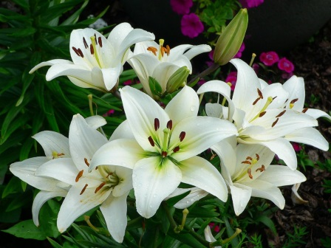 | Highly toxic to cats. Severe kidney damage
Marijuana |  | Depression of the central nervous system, vomiting, diarrhea, drooling, increased heart rate, seizures and coma
Sago Palms | 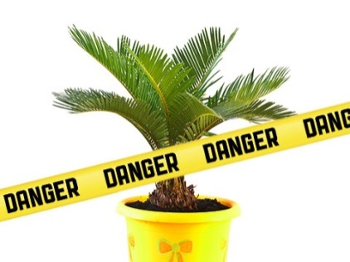 | Vomiting, diarrhea, lethargy, depression, black-tarry stool, seizures, liver failure, death
Tulips | 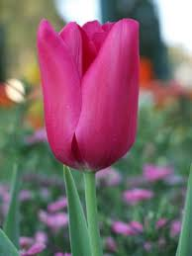 | Gastrointestinal irritation, drooling, loss of appetite, depression, convulsions, cardiac abnormalities
Azalea | 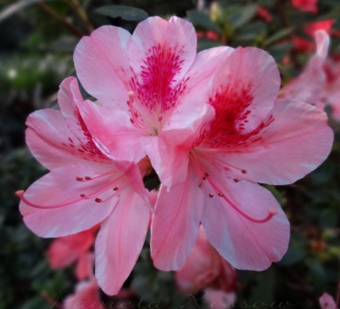 | Vomiting, drooling, diarrhea, weakness, depression, cardiovascular collapse, coma and possible death
Oleander | 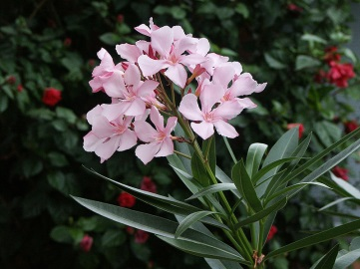 | Gastrointestinal irritation, abnormal heart function, hypothermia
Amaryllis |  | Vomiting, depression, diarrhea, abdominal pain, hypersalivation, anorexia and tremors
Chrysanthemum | 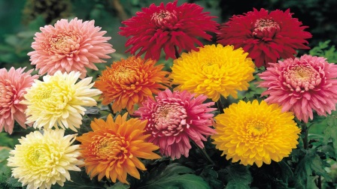 | Gastrointestinal upset, including drooling, vomiting, diarrhea
English Ivy | 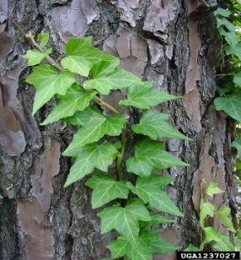 | Vomiting, abdominal pain, hypersalivation, diarrhea
Peace Lily |  | Oral irritation (mouth, lips, tongue), excessive drooling, vomiting, difficulty in swallowing, intense burning
Pothos | 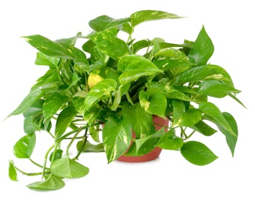 | Mechanical irritation, swelling of the oral tissues and other parts of the G.I tract
Poinsettia |  | Drooling, Repeatedly licking the lips, Irritation to the skin, face, lips, or nose, Red, itchy eyes, Diarrhea, Vomiting.

