- How does it work?
Laser Therapy FAQ
  - The laser works to produce more ATP, thus increase cellular activity. In effect, this stimulates blood circulation, while decreasing inflammation and pain.

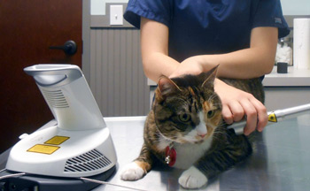
- What can be treated with laser therapy?
  - Laser Therapy can treat a wide range of cases, such as:
    - Arthritis
    - Back/Neck pain
    - Wounds
    - Surgery incisions
    - Trauma (skin, muscle, bone)
    - Hot spots

- How often will my pet need it?
  - We recommend starting with 6 sessions, getting 3 the first week, 2 the second week, and 1 the third week. Depending on their response and how they do, we hope to only have to do it once monthly to every 3 months.

- How soon will I see results?
  - Results are unique to each patient. Some see results after the first treatment, while others may take longer.

- How long does the treatment take?
  - It varies for each patient and what is being treated. One appointment can last around 20minutes. You will be able to stay in an exam room while the technician performs the laser therapy on the area specified by the doctor.

- Does it hurt?
  - No, your pet will not feel any pain. At most, he/she will feel a warm sensation to the area being treated. Many relax during the session.

- Are there any side effects?
  - There have not been any side effects reported. The laser therapy works to increase blood circulation at a cellular level. This actually works to decrease any pain.

