Food |  | Facts/Common Symptoms
Chocolate |  | - The darker, the more dangerous.  - Symptoms: vomiting, diarrhea, elevated heart rate, seizures, and death.
Grapes/Raisins |  | - Can cause kidney failure.  - Symptoms: Vomiting, diarrhea, lethargy, and excessive thirst/urination.
Onions, chives, garlic |  | - More dangerous to cats.  - Symptoms: Lethargy, weakness, ataxia, red/brown urine, hyper-salivation, vomiting/diarrhea.
Uncooked meat/eggs/bones |  | - Can cause pancreatitis  - Bones can splinter and cause obstructions and lacerations  - Symptoms: Vomiting and diarrhea.
Alcohol | 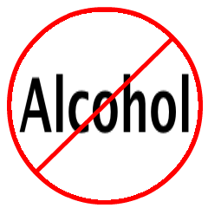 | - Hops are very toxic.  - Symptoms: hyperactivity, confusion, vomiting, seizures, and foaming of the mouth.
Caffeine | 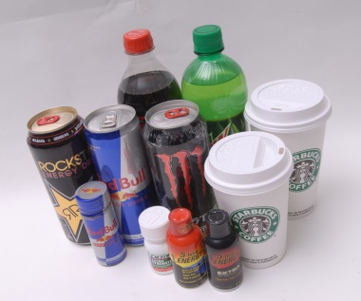 | - Is found in multiple products, i.e. coffee, soda, diet pills, etc.  - Symptoms: hyperactivity, restlessness, vomiting, tremors, seizures, and abnormal heart rhythms.
Salt |  | - Symptoms: Vomiting, Diarrhea, lethargy, excessive thirst, tremors, and seizures.
Yeast dough |  | - If ingested, yeast can multiply in the GI tract and cause an obstruction and alcohol intoxication.  - Symptoms: Lack of coordination, stupor and vomiting.
Avocado | 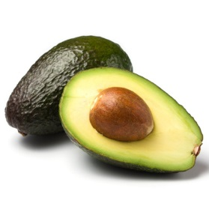 | - Ingestion of the pit can cause an obstruction.  - Symptoms: Gastrointestinal tract upset.
Xylitol (sugar) | 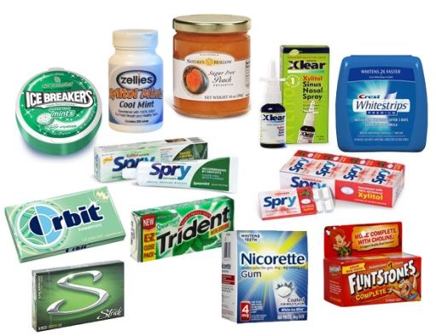 | - Is found in many products, i.e. gum, candy, baked goods, and tooth paste.  - Can lead to liver failure.  - Symptoms: Vomiting, diarrhea, lethargy, and loss of coordination.

Product |  | Facts/Symptoms
Prescription Medications (human and veterinary) |  | - Contact your veterinarian immediately if large amounts are consumed.  - Symptoms: Varies depending on medication but can cause increased heart rate, hyperactivity, and seizures.
Over-the-counter Human Medications | 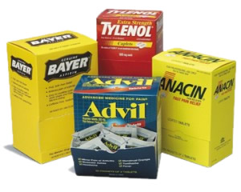 | - Tylenol, ibuprofen, and aspirin can cause liver failure.  - Symptoms: vomiting, abnormal stools, lethargy, excessive thirst/urination.
Over-the-counter Veterinary Medications | 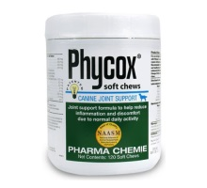  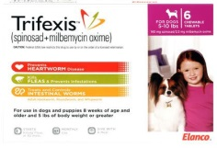 | - These are safe if recommended dose is given. Seek veterinary attention otherwise.  - Symptoms: varies depending on medication.
Insecticides/Fertilizers | 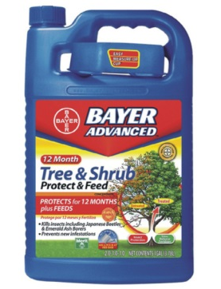 | - Always read label before using any product around your pet.  - Symptoms: vomiting, diarrhea, anorexia, lethargy, and seizures.
Rodenticides | 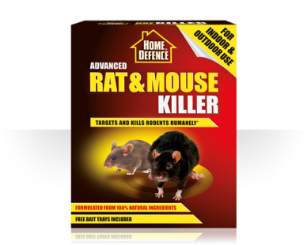 | - Symptoms: internal bleeding, kidney failure, or seizures.
Nicotine |  | - Symptoms: severe vomiting, depression, elevated heart rate, respiratory failure, and seizures.
Antifreeze | 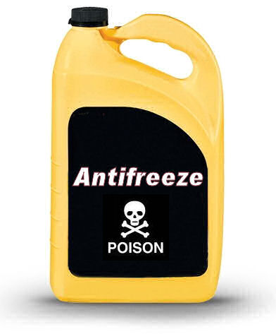 | - Commonly ingested from a car leak.  - Is EXTREMELY toxic!  - Symptoms: Uncoordinated movement, vomiting, diarrhea, rapid heartbeat, confusion, tremors, and seizures.

