LEPTOSPIROSIS

- Leptospirosis is a disease caused by Leptospira bacteria. These bacteria can be found in the soil and water in all parts of the world.

- Areas with warmer climates and high rainfall are more susceptible.
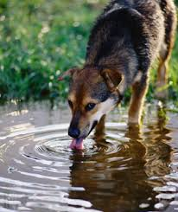
- Exposure to leptospirosis is through a bite from on infected animal or coming into contact with infected urine, water, soil, and food.

- Symptoms of Lepto can be vomiting, diarrhea, lethargy, and loss of appetite. In serious cases, kidney failure and death can occur if not caught early.

- If caught early, leptospirosis can be treated with antibiotics.
- Leptospirosis can be prevented by giving a yearly vaccine. It is recommended that your dog gets vaccinated if he/she is near any bodies of water, wildlife, or parks/wooded areas.
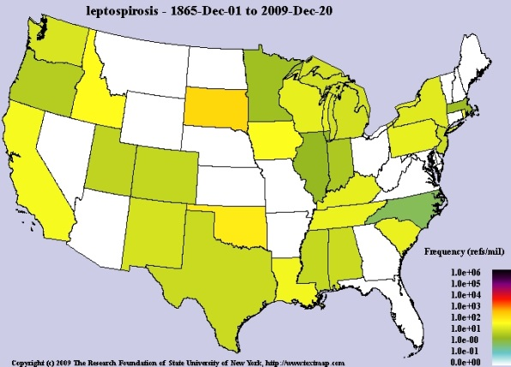

TICK-BORNE DISEASES
Ehrlichiosis
- Ehrlichia is found in the Lone-Star and Brown Dog tick. Both of which are common in Mt. Pleasant, SC.
- A tick infected with ehrichia must be attached for more than 36 hours before transferring the disease.
- Symptoms include:
  - Fever
  - Weight loss
  - Abdominal pain
  - Stiff and swollen joints
  - Anemia
- A positive blood test can diagnose ehrlichia.
- Several weeks of antibiotics will treat a dog positive for ehrlichiosis.
- A monthly dose of tick prevention can ensure you pet is protected.
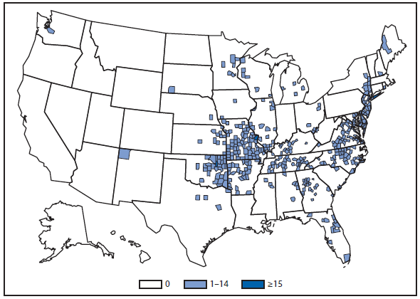

LYME
- Lyme disease is transmitted from an infected deer tick.
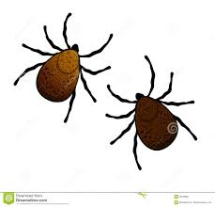
- A tick must be attached for at least 18 hours before lyme can be contracted.
- Symptoms include:
  - Fever
  - Lameness
  - Lethargy
  - Loss of appetite
- Diagnosing lyme is by a simple blood test performed by your veterinarian.
- Treatment is with a round of antibiotics.
- Prevention of lyme is by giving one dose of monthly flea/tick preventative or vaccinating in endemic areas.
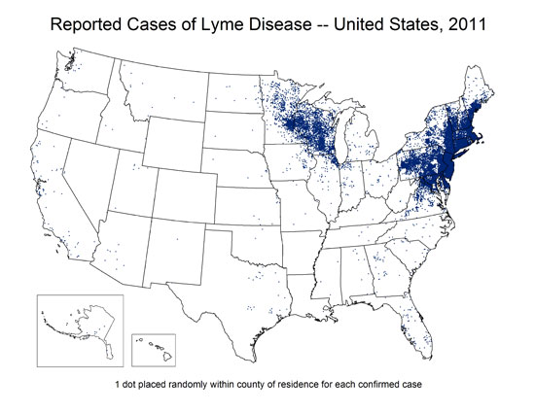
- Lyme disease is a concern in the north-eastern region of the United States.

